1. **Definition - What does *Cell Relay* mean?**

Cell relay is a network technology for data transmission that uses small data packets of a fixed size called cells. Cells are the basic units of data, and are widely used in common networks for communication.

**Cell relay** is extremely reliable for transporting vital data. Switching devices give the precise method to **cells** as each endpoint address embedded in a **cell**. An example of **cell relay** is ATM, a prevalent form utilized to transfer a **cell** with a fixed size of 53 bytes.

1. **Structure** of an **ATM cell**

An **ATM cell** consists of a 5-byte header and a 48-byte payload. The payload size of 48 bytes was chosen as described above. **ATM** defines two different **cell** formats: user–network interface (UNI) and network–network interface (NNI). Most **ATM** links use UNI **cell format**.

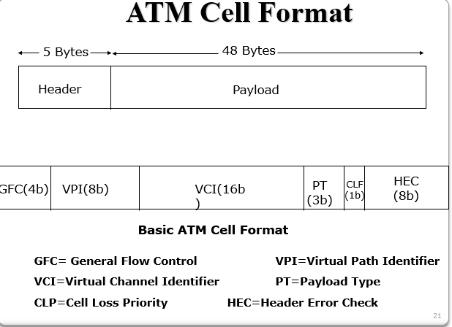

3.

4.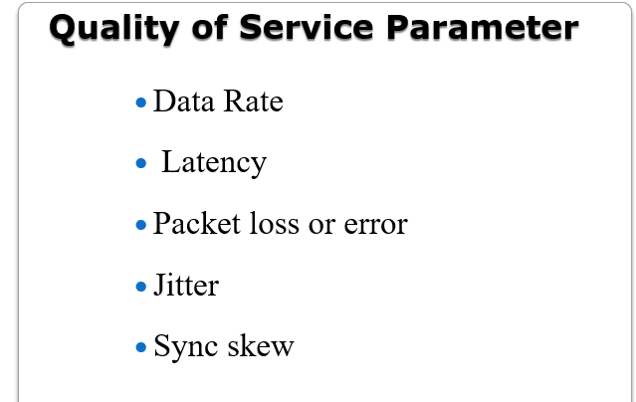

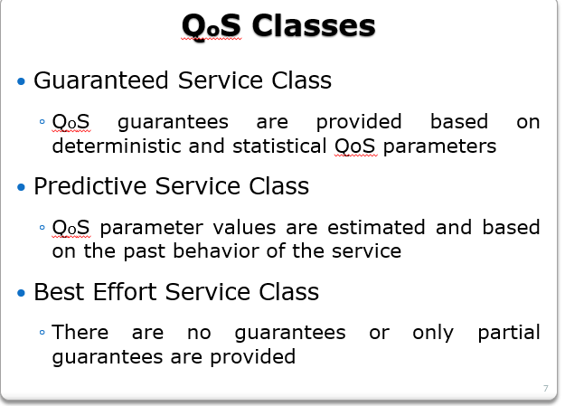

5. …………….

6.desig isuue of RTP

* RTP does **not** provide any mechanism to ensure timely data delivery or other QoS guarantees.
* RTP encapsulation is only seen at end systems (not) by intermediate routers.

routers providing best-effort service, making no special effort to ensure that RTP packets arrive at destination in timely matter.

7.RSVP use and operation

* RSVP: Resource Reservation Protocol
  + “ … allow users to communicate requirements to network in robust and efficient way.”

Operation:

* senders, receiver join a multicast group
  + - done outside of RSVP
    - senders need not join group
* sender-to-network signaling
  + - ***path message:*** make sender presence known to routers
    - **path teardown:** delete sender’s path state from routers
* receiver-to-network signaling
  + - ***reservation message:*** reserve resources from sender(s) to receiver
    - **reservation teardown:** remove receiver reservations
* network-to-end-system signaling
  + - **path error**
    - **reservation error**

8. RTSP use and operation

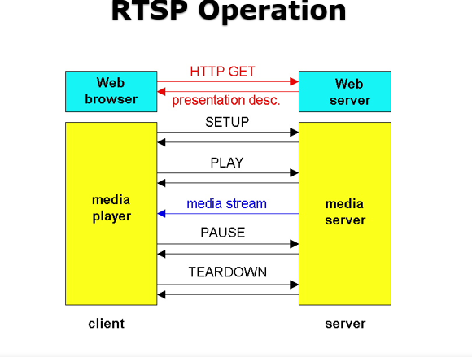

9. advantages of internet telephony over plain old telephone service

The two of its most important **advantages** are: Cost Reduction and Mobility. Reduced call charge is the main driving force behind the growing popularity of the IP **Telephony**. It costs much less to set up a packet-switched network (for **Internet** Protocol **Telephony**) than a circuit-switched network for PSTN.

* ability to utilise telephony services across devices (mobile phone, tablet, laptop). You are not tethered to a specific device
* More value added services (transcription, recording, conferencing, presence, etc)
* With traditional telephony, media is limited to voice. With internet telephony - video, instant messaging etc are super supported
* Generally cheaper
* More resilient - generally service outages do not last for days

10. describe the h.323 in internet telephony

323 endpoint and a Gatekeeper to provide address resolution and admission control services. **H**. 225.0 Call Signaling, which is used between any two **H**. 323 entities in order to establish communication.

11. describe the sip protocol in internet telephony

**Session Initiation Protocol** (**SIP**) is a signaling **protocol** used for initiating, maintaining, modifying and terminating real-time sessions that involve video, voice, messaging and other communications applications and services between two or more endpoints on IP networks.

Multimedia operating system

1. definition of pull server and push server file system

**Push** technology. ... **Push** technology, or **server push**, is a style of Internet-based communication where the request for a given transaction is initiated by the publisher or central **server**. It is contrasted with **pull**/get, where the request for the transmission of information is initiated by the receiver or client.

A DSC **pull server** (desired state configuration **pull server**) is an automation **server** that allows configurations to be maintained on many **servers**, computer workstations and devices across a network. ... Enabling or disabling **server** roles and features. Managing registry settings. Managing **files** and directories.

2.why traditional file system paradigm not applicable in multi. File system

* Traditional file systems perform an ***open***, several ***reads*** and ***close*** at the end
* During ***read*** operations, processes wait until I/O is finished but timing is not all that important. The data eventually comes.
* That is, the user pulls the data in one block at a time by repeatedly calling ***read*** calls to get one block after the other
* File servers of this type are often called ***pull servers*** (user pulls the data)
* For multimedia,
  + read calls must be at fairly specified times

***and***

* + the video server must be able to supply data blocks without a delay
* Multimedia file servers, after a ***start*** call, begin sending out frames at the required rate. It is up to the user to handle them.
* File servers of this nature are called ***push servers*** because they push data at the user.

1. what is multimedia operating system?

**operating systems** handle general data, like text files, programs, binary files, word-processing documents and also spreadsheets. ... **Multimedia** kind of data consists of continuous media in the form of files (audio or video) data as well as conventional files to run.

**3.**

**Rate- Monotonic Scheduling (RMS)**

* Designed/proved by Liu and Layland 1973
* **Policy:** task with highest rate has highest priority
* Static and optimal, priority-driven
  + Optimal means that there no other static algorithm that is able to schedule a RT task which can’t be scheduled by RMS algorithm
  + Assumptions:
    - Tasks are periodic
    - Each task must complete before next request
    - All tasks are independent
    - Run-time of each task request is constant
    - Any non-periodic task has no required deadline.

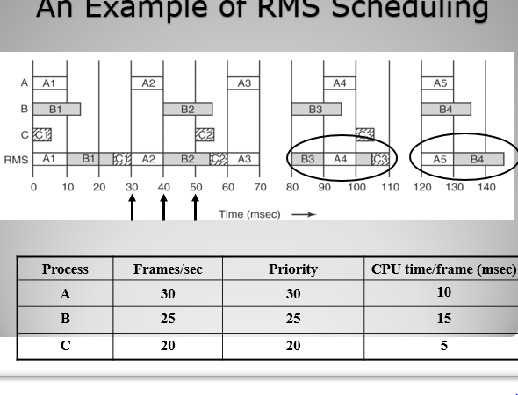

4.

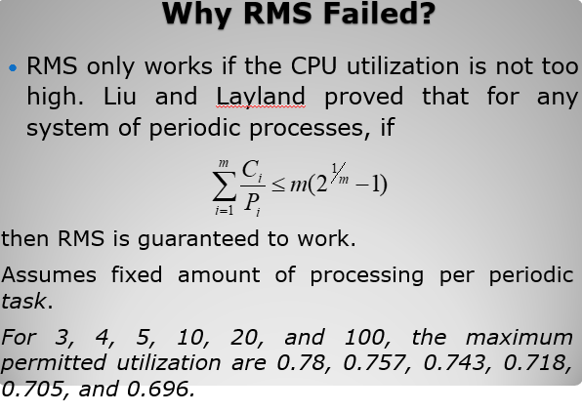

5. 